Hands-on Exercise No. 1  DigiSkills 3.0 Batch-03  Data Analytics and Business Intelligence | Total Marks: 10  Due Date: 30/04/2026

Hands-on Exercise No. 1
Data Analytics & Business Intelligence
DigiSkills 3.0 Batch-03

Name: | Zain Latif
Date: | 30-04-2026
Course: | Data Analytics & Business Intelligence

Task 1: XLOOKUP (Marks – 4)
XLOOKUP to fetch Sales, Quantity, Discount, and Profit columns from the Sales Data workbook into your current Data workbook based on the matching Product Name.
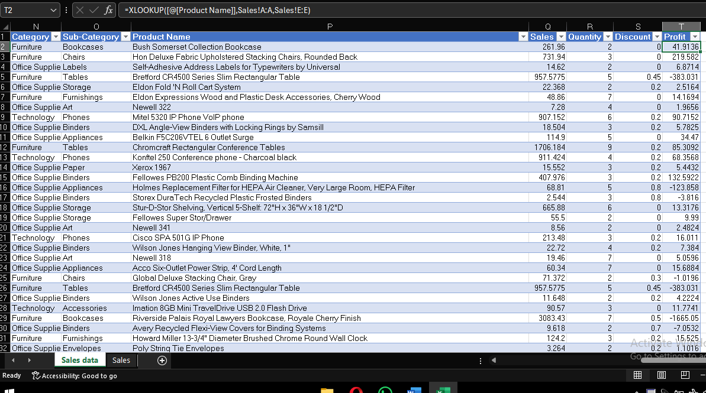

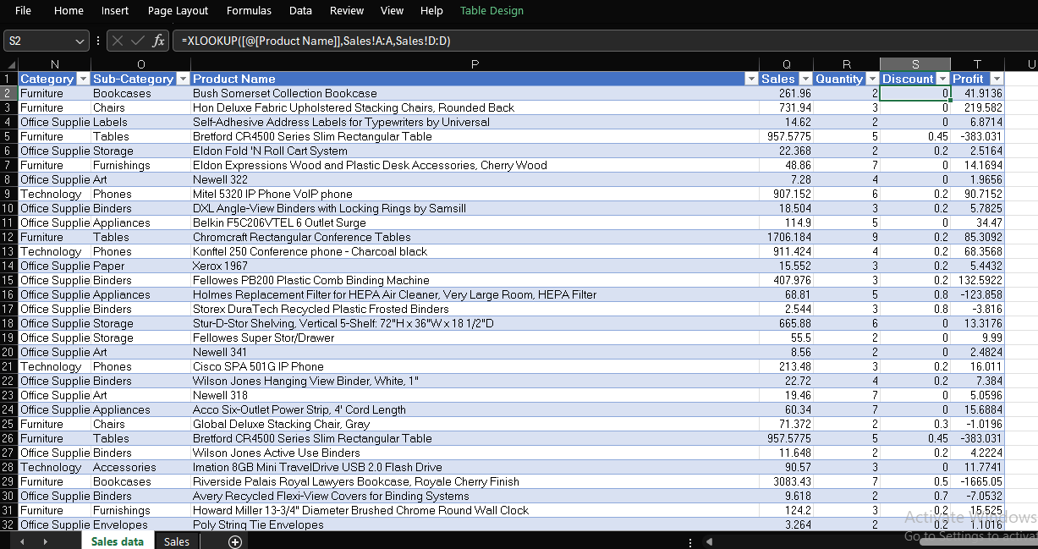

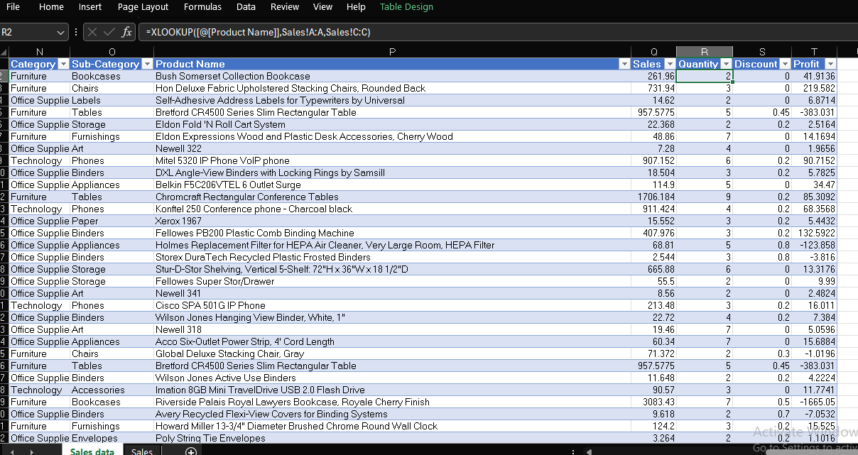

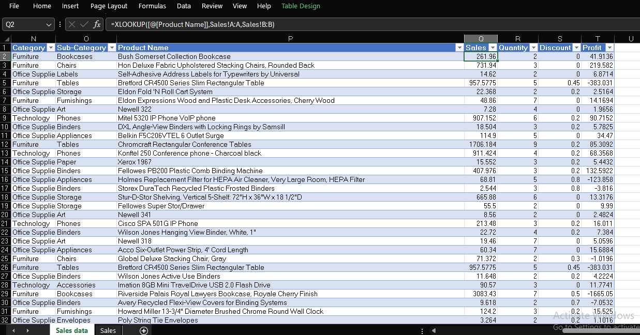

Task 3: Conditional Formatting (Marks – 2)
Use Conditional Formatting on the Sales column to highlight all values that are greater than 100.
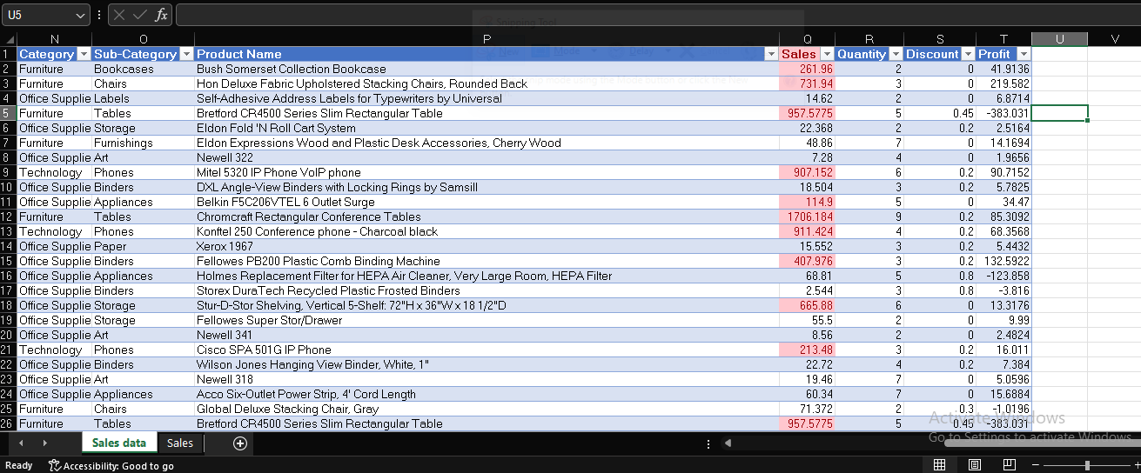

Task 4: Pivot Table (Marks – 2)
Create a Pivot Table to summarize total Sales by Category.
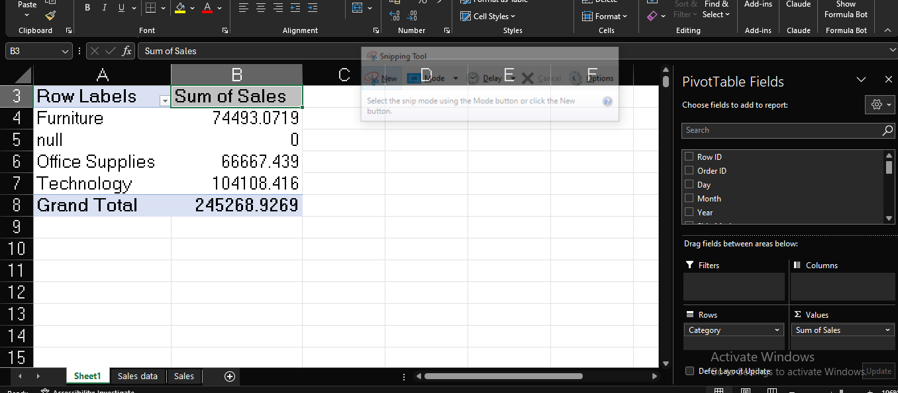

Task 5: Pie Chart (Marks – 2)
Create a Pie Chart to visualize total Sales by Category.
